7.2.8.2 Editors - 3D View - Header - Edit mode - Mesh menu
Detailed Table of content 2
Edit Mode - Mesh Menu 3
Transform 3
To Sphere 3
Usage 3
Last Operator Add Ico Sphere Panel 4
Factor 4
Proportional editing 4
Proportional Falloff 4
Proportional Size 4
Connected 4
Projected(2D) 4
Shear 4
Last Operator Shear 4
Offset 4
Shear Axis 4
Axis 4
Axis Ortho 5
Orientation 5
Proportional editing 5
Proportional Falloff 5
Proportional Size 5
Connected 5
Projected(2D) 5
Bend 5
Push/Pull 5
Last Operator Push/Pull 5
Factor 5
Proportional editing 5
Proportional Falloff 6
Proportional Size 6
Connected 6
Projected(2D) 6
Warp 6
Last operator Warp 6
Warp Angle 6
Offset Angle 6
Min 6
Max 6
Randomize Transform 6
Last Operator Randomize Transform 6
Amount 6
Uniform 6
Normal 7
Random Seed 7
Skin Resize 7
Last Operator Skin Resize 7
Vector 7
Scale X, Y, Z 7
Orientation 7
Proportional editing 7
Proportional Falloff 7
Proportional Size 7
Connected 7
Projected(2D) 7
Shrink/Fatten 8
Last Operator Shrink/Fatten 8
Proportional editing 8
Proportional Falloff 8
Proportional Size 8
Connected 8
Projected(2D) 8
Move Texture Space 8
Last Operator Translate 9
Move X, Y Z 9
Orientation 9
Proportional editing 9
Proportional Falloff 9
Proportional Size 9
Connected 9
Projected(2D) 9
Scale Texture Space 9
Last Operator Resize Texture 10
Move X, Y Z 10
Orientation 10
Proportional editing 10
Proportional Falloff 10
Proportional Size 10
Connected 10
Projected(2D) 10
Set Dimensions 10
Last Operator Set Dimensions 11
New Dimensions 11
Mirror 11
Interactive Mirror 11
X Global, Y Global etc. 11
Last Operator Mirror 11
Proportional editing 11
Proportional Falloff 12
Proportional Size 12
Connected 12
Projected(2D) 12
Mirror Vertex Group 12
Last Operator Mirror Vertex Group 12
Mirror Weights 12
Flip Group Names 12
All Groups 12
Topology Mirror 12
Snap 12

Detailed Table of content

Edit Mode - Mesh Menu

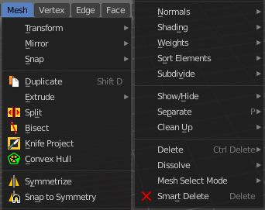
The Mesh Menu in Edit Mode contains the tools to manipulate the mesh geometry in Edit mode. It just exists for Mesh Objects.

Lots of functionality that could also belong here can also be found in the Tool Shelf. The difference is that the tools in the tool shelf are easier to access. And so it contains the most used tools for the daily work. While the Mesh menu contains the not so often used tools. Or tools where you use the hotkey anyway. Delete for example.

Transform


To Sphere
Shapes a selection of objects into the shape of a sphere. The calculation happens with the object origins.
In Object mode this tools requires to have more than one object selected.

Usage

Select the vertices, activate the tool, then drag the mouse in the 3D viewport. In the header you will read the current factor then. Which tells you how close you are towards the sphere shape.



Last Operator Add Ico Sphere Panel

Factor
The factor to transform the selection into a shape form.


Proportional editing
Enables proportional editing. Activating proportional editing reveals further settings.

Proportional Falloff
Here you can adjust the falloff methods.

Proportional Size
Here you can see and adjust the falloff radius.

Connected
The proportional falloff gets calculated for connected parts only.

Projected(2D)
The proportional falloff gets calculated in the screen space. Depth doesn't play a role. When it's in the radius, then it gets calculated.

Shear
Shear shears the selection.


Last Operator Shear

Offset
Here you can adjust an offset.

Shear Axis
The shear tool works along a imaginary 2d plane. The shear axis controls if the itemas are sheared along the x or the y axes of this plane. This is the plane along which the transformation happens. You can shear along the x or the y axis of this plane.
To make things even more complicated, the orientation of this imaginary plane is defined by the Axis and Axis Ortho items below.

Axis
Defines one axis of the imaginary shear axis plane.


Axis Ortho
Defines the other axis of the imaginary shear axis plane.

Orientation
Here you can choose the orientation for the shear action.

Proportional editing
Enables proportional editing. Activating proportional editing reveals further settings.

Proportional Falloff
Here you can adjust the falloff methods.

Proportional Size
Here you can see and adjust the falloff radius.

Connected
The proportional falloff gets calculated for connected parts only.

Projected(2D)
The proportional falloff gets calculated in the screen space. Depth doesn't play a role. When it's in the radius, then it gets calculated.

Bend
Bends the selection.

Push/Pull
It pushes or pulls the object positions relative to the center of the selection.
In Object mode this tool requires to have more than one object selected.


Last Operator Push/Pull

Factor
Here you can adjust the strength of influence of the tool.

Proportional editing
Enables proportional editing. Activating proportional editing reveals further settings.

Proportional Falloff
Here you can adjust the falloff methods.

Proportional Size
Here you can see and adjust the falloff radius.

Connected
The proportional falloff gets calculated for connected parts only.

Projected(2D)
The proportional falloff gets calculated in the screen space. Depth doesn't play a role. When it's in the radius, then it gets calculated.


Warp
Warps a mesh selection between two defined points.

Last operator Warp

Warp Angle
The strength of the warp effect

Offset Angle
A offset angle to bend sidewards.


Min
The start point.

Max
The end point.

Randomize Transform
This tool allows randomizes the positions of the selected vertices.


Last Operator Randomize Transform

Amount
Here you can adjust the amount.

Uniform
The uniform offset distance.

Normal
Align the offset direction to the normals.

Random Seed
The seed value for randomization.

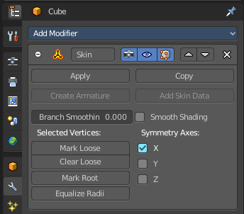
Skin Resize
This tool requires to have a skin modifier at the mesh. It scales the thickness of the skin.
While the operation you will see in the header the strength value for the skin.

Last Operator Skin Resize

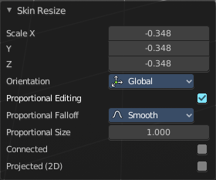
Vector
Here you can adjust the position values for the three values.

Scale X, Y, Z
Here you can limit the position relative to the source object.

Orientation
Orientation is a drop-down box where you can choose the type of orientation for the mirroring action.

Proportional editing
Enables proportional editing. Activating proportional editing reveals further settings.

Proportional Falloff
Here you can adjust the falloff methods.

Proportional Size
Here you can see and adjust the falloff radius.

Connected
The proportional falloff gets calculated for connected parts only.

Projected(2D)
The proportional falloff gets calculated in the screen space. Depth doesn't play a role. When it's in the radius, then it gets calculated.

Shrink/Fatten
Shrink/Fatten scales the selected geometry along its normals. Transform orientation and Pivot point gets ignored.
A positive value pushes the vertices outwards. A negative value pushes the vertices inwards.


Last Operator Shrink/Fatten
The Last Operator Shrink/Fatten panel gives you tools to adjust the Shrink/Fatten operation. Here you have numeric input for the strength and a few more options.

Offset
Offset is the strength of the offset for Shrink/Fatten.

Offset Even
Offset Even scales the selection to give more thickness in even areas.

Proportional editing
Enables proportional editing. Activating proportional editing reveals further settings.

Proportional Falloff
Here you can adjust the falloff methods.

Proportional Size
Here you can see and adjust the falloff radius.

Connected
The proportional falloff gets calculated for connected parts only.

Projected(2D)
The proportional falloff gets calculated in the screen space. Depth doesn't play a role. When it's in the radius, then it gets calculated.


Move Texture Space
This tool relies at the move tool. With the difference that it moves the texture space instead of the object. It has also a very special use case, and just works with a material with a Texture Coordinate / Generated node. And requires to have the shading at Material or Rendered to see a result in the viewport.
In the viewport you will see the UV cage in black color. In the header you will see the values for the current position of the UV cage.
Note that once done and applied, there is no way to reset the UV cage back to zero. When you repeat the operation, then the values will start at 0 again. Even when the UV cage is already offset.



Last Operator Translate

Move X, Y Z
Here you can limit the position relative to the source object.

Orientation
Orientation is a drop-down box where you can choose the type of orientation for the mirroring action.

Proportional editing
Enables proportional editing. Activating proportional editing reveals further settings.

Proportional Falloff
Here you can adjust the falloff methods.

Proportional Size
Here you can see and adjust the falloff radius.

Connected
The proportional falloff gets calculated for connected parts only.

Projected(2D)
The proportional falloff gets calculated in the screen space. Depth doesn't play a role. When it's in the radius, then it gets calculated.


Scale Texture Space
This tool relies at the scale tool. With the difference that it scales the texture space instead of the object. It has also a very special use case, and just works with a material with a Texture Coordinate / Generated node. And requires to have the shading at Material or Rendered to see a result in the viewport.
In the viewport you will see the UV cage in black color. In the header you will see the values for the current position of the UV cage.
Note that once done and applied, there is no way to reset the UV cage back to zero. When you repeat the operation, then the values will start at 0 again. Even when the UV cage is already offset.



Last Operator Resize Texture

Move X, Y Z
Here you can limit the position relative to the source object.

Orientation
Orientation is a drop-down box where you can choose the type of orientation for the mirroring action.

Proportional editing
Enables proportional editing. Activating proportional editing reveals further settings.

Proportional Falloff
Here you can adjust the falloff methods.

Proportional Size
Here you can see and adjust the falloff radius.

Connected
The proportional falloff gets calculated for connected parts only.

Projected(2D)
The proportional falloff gets calculated in the screen space. Depth doesn't play a role. When it's in the radius, then it gets calculated.


Set Dimensions
Edit Mode Only!
Normally all scale operations in Bforartists are relative to the current selection and dimensions. And you always start with a relative value of 1.
Set dimensions allows to scale mesh selections in absolute world values. No matter how the initial values are. The new values gets set in the Last Operator.
Set dimensions is an add-on. You can turn it off in the add-ons section of the user preferences when you want.

Last Operator Set Dimensions


New Dimensions
When you activate the tool then you will see the world coordinates of the selection. Here you can change the values to other world coordinates.

Mirror


Mirror mirrors the selected geometry along the defined axis.

Interactive Mirror
Mirror by hotkeys. You activate the tool, type in x for x global for example, or x x for x local. And the selection gets mirrored

X Global, Y Global etc.
Mirrors the selection around the chosen axis.

Last Operator Mirror

The Last Operator Mirror panel gives you tools to adjust the mirror action.

Orientation
Orientation is a drop-down box where you can choose the type of orientation for the mirroring action.

Constraint Axis
Constraint Axis gives you again the possibility to define the mirror axis. You can choose more than one axis here.

Proportional editing
Enables proportional editing. Activating proportional editing reveals further settings.

Proportional Falloff
Here you can adjust the falloff methods.

Proportional Size
Here you can see and adjust the falloff radius.

Connected
The proportional falloff gets calculated for connected parts only.

Projected(2D)
The proportional falloff gets calculated in the screen space. Depth doesn't play a role. When it's in the radius, then it gets calculated.

Mirror Vertex Group
This tool requires to have a vertex group assigned. It mirrors the selected vertex group.
This tool works only with a perfectly symmetrical mesh along the local X axis. Vertices that have no corresponding vertex on the other side will not be affected.

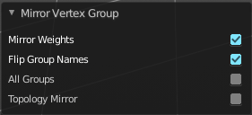
Last Operator Mirror Vertex Group

Mirror Weights
Mirrors the Weight Painting informations from the symmetrical counterpart. When both are selected it will become a group and weight information exchange. If only one is selected, then the information from the unselected vertice will go to the selected vertice.

Flip Group Names
Flip selected group names. This works with vertex groups with symmetrical name conventions. Like .L , .R, right, left.

All Groups
Pass information to all groups instead of the active one.

Topology Mirror
Use topology based mirroring.

Snap

Here you can choose several methods to snap one element to another. The menu items should be self explaining.

Last Operator Snap

Some snap operations shows a last operation panel, some not.

Offset
If the selection should snap as a whole, or if each individual element of the selection should snap.

Single Operators

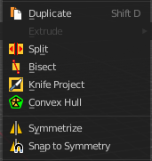
Duplicate
Duplicates the current selection.
When you duplicate a selection, then it sticks to the mouse until you left click. And moves around. A right click repositions the duplicated geometry at its original location.

Last Operator Duplicate

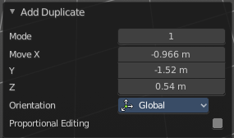
Mode
Not to find out. No tooltip, no entry in the Blender manual. Good Job Blender Developers.

Move X, Y, Z
Here you can adjust the position.

Orientation
Orientation is a drop-down box where you can choose the type of orientation for the mirroring action.

Constraint Axis
Constraint Axis gives you again the possibility to define the mirror axis. You can choose more than one axis here.

Proportional editing
Enables proportional editing. Activating proportional editing reveals further settings.

Proportional Falloff
Here you can adjust the falloff methods.

Proportional Size
Here you can see and adjust the falloff radius.

Connected
The proportional falloff gets calculated for connected parts only.

Projected(2D)
The proportional falloff gets calculated in the screen space. Depth doesn't play a role. When it's in the radius, then it gets calculated.

Split
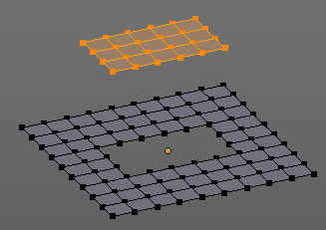
Split splits the edges between the selected vertices. It creates two edges out of one. And splits the edge by that.
The mode doesn't matter. There will always the edges be splitted.

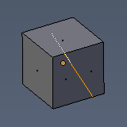
Bisect
Bisect cuts geometry along a plane. This description is a bit misleading though. You simply cut through the whole geometry by defining a line. And the cut goes through the geometry from the current view.

Last Operator Bisect

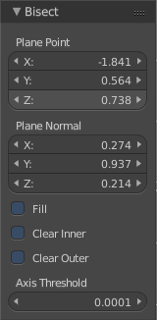
Plane Point
Defines the start point of the Bisect cut.

Plane Normal
The direction in which the bisect points.

Fill
Fills the cut

Clear Inner
Removes the inner part of the face to cut.

Clear Outer
Removes the outer part of the face to cut.

Axis threshold
Axis threshold.

